**Course Project   
DeVry University  
College of Engineering and Information Sciences**

**Course Number: CEIS236**

**Course Project Deliverable: 4**

**PART I:**

Question 1.

* Customer - PK : Cus_Code
  + FK: None
* Invoice – PK: Inv_Number
  + FK: Cus_Code is a FK to the costumer table
* Line – PK: Inv_Number, Line_Number
  + FK: Inv_Number is FK to Invoice table, P_Code is FK go the Product table
* Product – PK: P_Code
  + FK: V_Code is FK to the Vendor table
* Vendor – PK: V_Code
  + FK: None

Question 2. Yes, the data in the primary key fields are all unique and there are no nulls in the primary key fields.

Question 3.

* Customer: N/A
* Invoice: Yes, all foreign key values point to records that exist in the related Customer table.
* Line: Yes, all foreign key values point to records that exist in the related Invoice and Product tables.
* Product: Yes, all the foreign key values point to records in the related Vendor table or values are null.
* Vendor: N/A

Question 4. Each Customer can have many Invoices, however, each Invoice can only be associated with one Customer. This is a One-to-Many relationship – 1:M

Question 5. Invoices and Product have a Many-to-Many relationship – M:N. One Invoice can have many Product items, and one Product item can be listed on many Invoices. The Line table is the linking table or associated table between the two M:N tables.

Question 6.

**PART II:** ERD

Player – player_id, first_name, last_name, age

Parents

Team – team_id, name, colors

Coach

Business Rules

Player is on one Team only; Each Team can have many Players – 1:M

Coach is on one Team only; Each Team can have many Coaches – 1:M

Player can have many Parents; Parent can have many Players – M:N

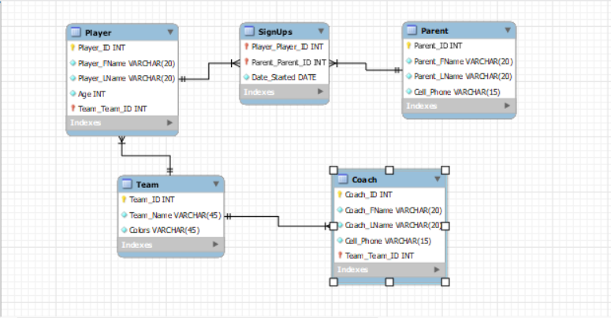

**PART III:** Create Dependency diagram

Appointment

App_Num(PK)

Doc_EmpID (FK)

App_Date

App_Time

App_PatientID

App_Name

App_Phone

App_Street

App_City

App_State

App_Zip

App_Status

Doc_EmpID (PK)

Doc_FName

Doc_LName

Doc_CellPhone

Doctor

Fixed to 3NF Below

App_Num(PK)

Doc_EmpID (FK)

App_Date

App_Time

App_PatientID

App_Status

Appointment

\

PatientID

Patient_Name

Patient_Phone

App_Street

Patient_City

Patient_State

Patient_Zip

Patient

Doc_EmpID (PK)

Doc_FName

Doc_LName

Doc_CellPhone

Doctor